Introduction & Project Objective
The purpose of this project is to build a Sentimental Analysis program that determines whether a user’s input text expresses a Positive, Negative, or Neutral sentiment.
The program analyzes sentences entered by the user and calculates a polarity score based on emotional intensity, negation words, and sentiment-bearing keywords.
Problem it Solves
People often need quick ways to identify the emotional tone of statements, such as:
- Customer reviews
- User feedback
- Social media comments
- Surveys and forms
This program automates that process.
Intended Users
Anyone who needs simple sentiment classification, especially beginners learning Natural Language Processing (NLP).

Methodology / Code Explanation
1. Program Structure
The program consists of the following components:
- Importing Libraries: Uses nltk and regular expressions.
- Sentiment Lists: Predefined lists of negation words and intensifiers to modify the score.
- Main Function (analyze): Computes sentiment using both VADER and custom rules.
- Interactive Loop: Allows users to repeatedly input text.

2. Key Functions
analyze(txt)
This is the core function of the program. It:
- Calculates VADER’s built-in compound score
- Breaks the text into words
- Applies intensifiers (e.g., "extremely", "very")
- Detects negation words (e.g., "not", "never")
- Adjusts the sentiment score for each sentiment-bearing word
- Computes final polarity
- Returns:
  - Sentiment label (Positive/Negative/Neutral)
  - Polarity value
  - Keywords contributing to the sentiment

3. Libraries Used
Library | Usage
nltk.sentiment.vader | Provides the base sentiment analysis model (VADER).
re | Used to clean words by removing punctuation.
nltk.download() | Ensures the VADER lexicon is available.

These allow the program to detect sentiment patterns and process text efficiently.

4. Logic & Flow of the Program
- User enters text
- Program cleans & splits the text
- VADER scores each word
- Check for intensifiers within 2 previous words
- Check for negation within 3 previous words
- Modify the score accordingly
- Average score + VADER compound score → final polarity
- Classify sentiment:
  - Polarity > 0.05 → Positive
  - Polarity < –0.05 → Negative
  - Otherwise → Neutral
- Display the results
This hybrid method combines traditional VADER sentiment analysis with custom rule-based logic to improve accuracy.

Results & Output
Below is an example of how the program runs in the terminal:

Example 1:
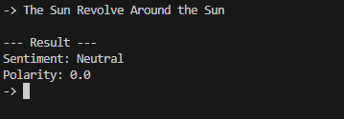

Example 2:
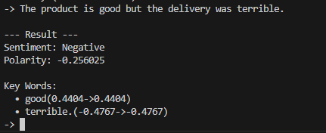

Example 3:
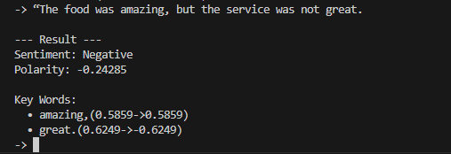

Challenges & Solutions:

Challenge | Solution
Understanding how VADER works internally | Researched documentation and experimented with sample text
Handling negations properly | Added custom list of negation words and reversed sentiment values when detected
Dealing with intensifying words like “very”, “extremely” | Created a dictionary of intensifiers with different multiplier strengths
Combining VADER score with custom logic | Computed weighted average of built-in and custom scores

Conclusion & Learning Outcomes
This project successfully implements a Sentimental Analysis tool using Python, VADER, and custom NLP rules.
It demonstrates how text preprocessing, negation handling, and intensity modifiers influence sentiment classification.
What I Learned
- How to use the NLTK VADER sentiment analyzer
- How to apply rule-based sentiment corrections
- How intensifiers and negations change emotional meaning
- How to interactively run Python programs in a loop
- How to combine multiple scoring methods to improve results

